1. **Introduction**

The purpose of this work is to simulate the behavior of an *E.Coli* under the action of a flow. To do so, it is necessary to successfully simulate the force done by the fluid over the bacteria, the force that the pilis make over the bacteria (which is a non-lineal response), and the adhesion between the pili and the walls. The final aim of this work is observe the collective behavior of all the system in different scales: micro (fluid), meso (pili), and nano (adhesive molecules).In particular, it’s of great interest to see the collective behavior of the system when the bacteria moves against the current, fact observed by  [1]. The motivation for studying this phenomenon through simulation is because is not possible to see the underlying mechanism in the system directly, and then is necessary to study them by using numerical simulations.

The reason that drives this work is that infections that occurs within the urinary are identical to the situation modeled, so understating this scenario in detail is valuable for developing treatments for these kind infections especially considering that they are becoming harder to treat as antibiotics have been losing their efficiency.

Some of following works give an insight of work done here: in [3] a simulation is done where only a deterministic behavior was considered, and it was modeled only through the use of differential equations. The results obtained resemble what was had been seen experimentally. In a similar way, in  [4] a simulation of the process of elongation was done by seeing the pili as rigid body system and was modeled through the use of the Euler-Newton equations. The results in this case also resembled the experimental observation, bus as [3] stochastic fluctuation were ignored.

In [5] the method of Monte Carlo–Metropolis was used to simulate the stochastic behavior of the adhesion, and it was possible to observe that the life-time of a bond depends on the amount of cooperation between the pilis. This cooperation in turn depends of the mechanical properties (like its helical structure and its ability to unbind), which itself depends on the length of the subunits and the energy of the bonds. In particular, it was observe that by decreasing the length of the bond by half the lifetime decreased by three orders of magnitude.

In  [6], a simplified situation was simulated where the pili was considered as only a hook spring and while a stochastic simulation was used for the Catch Bond. In the work, the focus was to study how the bacteria can roll in the direction of a flow but after a critical velocity the bacteria seems to be anchor in the surface. It was concluded that the anchoring is result of a larger number of pilis attach to the surface and not directly related to the catch bond. Additionally, it was notice that this behavior is tolerant to the changes in the parameters. Another relevant work about the catch bond is  [7], here an scenario simplified to two dimension is simulated and from this work is concluded that the pili works as a damper that allows the force receive by the pili as of strength such that the catch bond enters its more resistant state.

1. **Catch Bond**

Certain receptor-ligand bonds have shown an increase in their average time of life when a tensile mechanical force is applied over them, these bonds are referred as Catch Bond. A kind of catch-bond (film-H) is present at the extremes of the pili of E-Coli, so it simulation is necessary to describe the behavior of the adhesion.

The behavior of the Catch Bond can be describe on the following way; the configuration of any molecule (including film-H) can be understood as an energy landscape where all possible configuration of a molecule are described by the degrees of freedom of the molecule itself. These degrees of freedom have a corresponding energy, so if particles have N degrees of freedom; it has a N+1 dimensions energy landscape where the extra dimension describes the energy of each configuration. In this space, local minimums are potential wells, where the system is stable. If a system is inside one of those wells there is a certain rate for the system to escape them, which is explain by the Bell model: $k=A∙e^{\frac{-∆E+f∙∆x}{k_{b}∙T}}$ Where A is the attempt rate and the delta of energy describes how deep the potential well is.

When a force $f$ is an over the bond, it affects the rate because a force will usually generate a deformation in the bond, which is a change in the average length of it. This deformation translates in a change in the energy by the amount of $f∙∆x$, this in turn changes the rate in the following way $:$

$$k(f)=A∙e^{\frac{-∆E+f∙∆x}{k_{b}∙T}}=k^{o}∙e^{\frac{f∙∆x}{k_{b}∙T}}$$

In the case of the Catch Bond, there exist two states which by themselves to local minimums (where one is deeper than the other) separated by a potential barrier which divides them. The action of the force applied to the systems lowers the barrier between the wells enough, so the transition rate between those two states becomes higher, so in terms of the master equation the system is describe by the following two equations:

|  |  |
| --- | --- |
| State | Master equation |
| 1 | $$\dot{p_{1}}={-k}_{10} (f)-k_{12} (f)$$ |
| 2 | $$\dot{p_{2}}={-k}_{20} (f)-k_{21} (f)$$ |

As the evolution of the system depends on the transition rates, a good way to simulate is through the application of the Gillespie Algorithm. This algorithm provides a solution to the master equation, which describes the evolution of the system. It consists of the following steps:

* The rates is normalized to its sum is equal to one and different sections of the interval [0, 1] are assigned to each rate.
* A uniform random number is generated and depending where it lands in the interval a different action takes place
* The moment in which the selected event takes place is decided through an exponential distribution which has a mean equal to the sum of all rates of transition.
* In the particular case, the system begins in the state one and changes into the state 2 the rates of $k_{10}(f)$ and $k_{12}(f)$ are exchanged for $k_{20}(f)$ and $k_{21}(f)$ and this happens is the inverse direction.

For the validation the following was done, a sample of 200 simulations of filmH were exposed to the same force, in time the fraction in all cases begin to reduce but the samples exposed to the a higher force show a longer survival fraction. The plot 1 show the results

Additionally another test was made, in this a samples of 80000 simulations of filmH were exposed to a force in the range between 0 and 60 pN, for each simulation the it took time to escape the well and registered and the mean between the 80000 repetitions was taken. The result validate the effectiveness of this simulation as it shows the expected behavior as the mean-life time increases as the force also increased until a inflection point is reached and the life time begins to sharply decrease. The results are in plot 2.

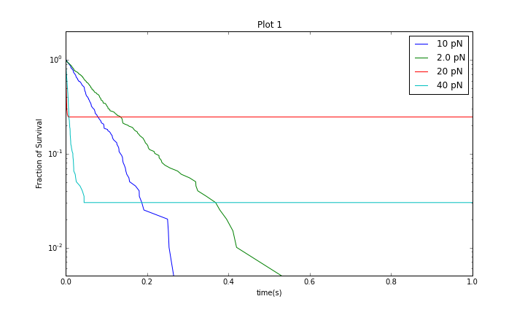

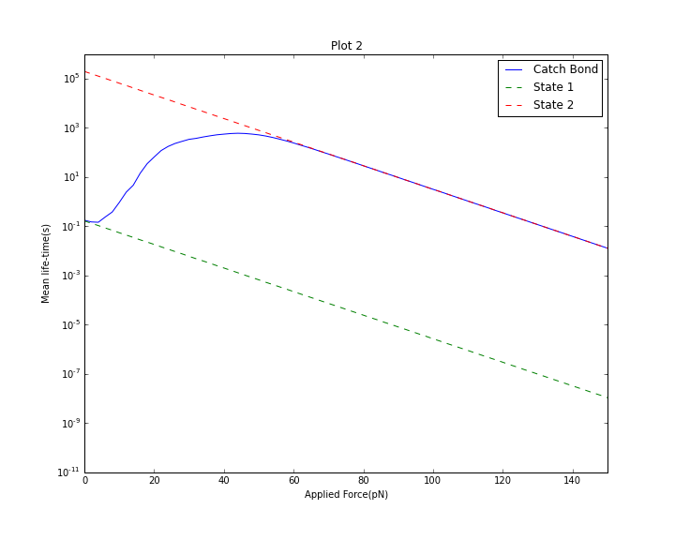

In the parameters used in the simulation are the same as the used in the -…..- The resul

1. **Pili**

The method used to simulate the force generated by the extension of the pili is largely base in the idea proposed by …. . The pili is seen as a compound spring made up of two distinct sections, one that is a hookean spring and other that follow a model known as worm like chain, which are connected in series. When the monomers are in their retracted state, they behave as a hookean spring, and when they are not retract, they behave as a polymer chain, which is described through the worm like chain mode. It is supposed that the force is uniform throughout all the pili, and this allows equal the two expressions that describe the extension-force relations, and obtain a relationship that gives the extension of a particular section of the pili in function of the extension of the whole. Then by knowing how much the hookean section deforms is possible to know how much force produces and because the force is the same in all the spring then the force produce by the elongation of the whole spring is known.

The force induces an effect similar to the one explained in the case of the catch-bond, as it leads to a change in the probability of transition between the closed and open states, and through t. The only monomer that can undergo this transition is the one in the interphase between the sections. A Monte Carlo-Metropolis simulation is used in this case in the following way:

The rate of opening is the monomer is given by the expression:

$$k^{o}∙e^{\frac{f∙∆x}{k_{b}∙T}}$$

This rate is compared to a uniform random number contained in the interval [0,1]. If the number is higher than the rate then the transition is approved thus a change takes place, but if it is not higher nothing happens. So in every time interval two of this transition rates are observed, the one opening and closing ones to see if the last opened monomer closes and the last closed opens.

1. **Latttice Boltzman**

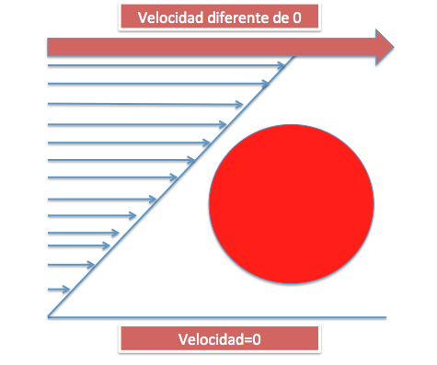

Graph 1.

La monografía consiste de la integración de 3 componentes distintos:

* Simular la dinámica de un objeto (por simplicidad se considera usar una esfera) en un fluido.
* Simular el modelo de adhesión de catch-bond.
* Simular la respuesta de desplazamiento al forzar un pili.

Para simular el movimiento que tiene un objeto se considera un flujo, el cual posee una pared con una velocidad constante y otra con una velocidad de cero, lo cual crea un perfil de velocidades que crece a medida que uno va de una pared a otra. La razón para considerar un dominio de esta forma es que los conductos, con es el caso de un tracto urinario, en realidad tienen un perfil de velocidades parabólico (flujo de Poiseuille), pero como se está observando una vecindad muy pequeña cerca a la pared el perfil parabólico se puede ver como uno lineal (gráfica 1).

El método computacional que se usa para realizar toda la simulación (*Lattice-Boltzman*) consiste en que se resuelve la ecuación de Boltzman discreta junto con un modelo de colisión, esto a si vez termina resolviendo indirectamente la ecuación de Navier-Stokes. La idea básica es la siguiente: se convierte el espacio en una malla discreta y se supone un grupo de partículas. En cada instante de tiempo las partículas se mueven de un nodo de la malla a otro, y en el caso de que caigan dos partículas en el mismo nodo se aplica el modelo de colisión y las partículas se arrojan a otro nodo producto debido a esto. La idea general de este método es que promediando el comportamiento microscópico que tienen las partículas, surge el comportamiento macroscópico que se observa experimentalmente.

Explícitamente, cada nodo de posición $\vec{x}$, en el tiempo $t$, tiene una densidad de partículas $f_{i}\left(\vec{x},t\right)$. Los subíndices denotan la dirección a la que se propagan las partículas, por ejemplo para el nodo con posición $\vec{x}$ la densidad $f_{1}\left(\vec{x},t\right)$ da el número de partículas que se mueven hacia arriba, la densidad $f_{2}\left(\vec{x},t\right)$ da el número de partículas que se mueven hacia abajo, etc…. Adicionalmente se considera que la velocidad de progación es solo la suficiente para llegar al vecino más cercano en una unidad de partición del tiempo. Considerando esto, la evolción temporal del sistema es la sigueinte: en cada instante, por lo descrito previamente, llega un un número de partículas provenientes de los vecinos más cercanos a un nodo, en el caso de no considerar algún tipo de colisión se tendrían las mismas densidades de sus vecinos (esto sería en términos más simples que tendría el mismo número de partículas moviéndose abajo que tenia el nodo directamente arriba, el mismo número moviéndose a la derecha que tenia el vecino de la izquierda,etc…). Luego como se consideran colisiones entonces estas densidades fluctuan por lo choques ya que las partículas se encuentra en el nodo chocan y eso cambia su dirección de progación y luego la densidad. Esta evolución es descrita por la siguiente ecuación: donde ${{ f}_{i}}^{0}\left(\vec{x},t\right)$ es la densidad en el equilibrio, $τ$ es el tiempo de relajación, y $f_{i}\left(\vec{x}+\vec{δ_{i}} ,t+1\right)$ es la densidad en un nodo vecino en un instante en el futuro:

$$f_{i}\left(\vec{x}+\vec{δ_{i}} ,t+1\right)=f_{i}\left(\vec{x},t\right)-\frac{1}{τ}\left(f_{i}\left(\vec{x},t\right)-{f_{i}}^{0}\left(\vec{x},t\right)\right)$$

El término que describe el fenómeno de colisión es: $\frac{1}{τ}\left(f_{i}\left(\vec{x},t\right)-{f_{i}}^{0}\left(\vec{x},t\right)\right)$. Este término depende de que tan cercano este la densidad de un nodo a la densidad de equilibrio, lo que significa que cuando se este en equilibrio este efecto de colisión desaparece, lo cual tiene sentido ya que si se encuentra en estado estable el sistema no debe fluctuar en el tiempo.

1. **Referencias**

[1] D. E. Rangel, N. Marín-Medina, J. E. Castro, A. González-Mancera, and M. Forero-Shelton, PLoS ONE **8**, e65563 (2013).

[2] Michael C. Sukop and Daniel T. Thorne, Jr., *Lattice Boltzmann Modeling- An Introduction for Geoscientists and Engineers*, 2nd ed. (Springer, Miami FL, 2007).

[3] M. J. Whitfield, J. P. Luo, and W. E. Thomas, PLoS Comput Biol **10**, e1003971 (2014).

[4] J. Zakrisson, K. Wiklund, M. Servin, O. Axner, C. Lacoursiere, and M. Andersson, ArXiv14114416 Phys. (2014).

[5] O. Björnham and O. Axner, J. Chem. Phys. **130**, 235102 (2009).

[6] M. Whitfield, T. Ghose, and W. Thomas, Biophys. J. **99**, 2470 (2010).

[7] J. Zakrisson, K. Wiklund, O. Axner, and M. Andersson, Biophys. J. **104**, 2137 (2013).

[8] J. Zakrisson, K. Wiklund, O. Axner, and M. Andersson, ArXiv150802563 Phys. (2015).

[9] Cyrille Rossant, *IPython Interactive Computing and Visualization Cookbook* (Packt Publishing, 2014).